Research outline

Phenotypic and functional traits [do not?] affect species detectability in Swiss butterflies.

Christian König, Gurutzeta Guillera‐Arroita, Florian Altermatt, Guillermo Fandos-Guzman, Tobias Roth, Dirk Zeuss, Damaris Zurell

Target journals: Ecology, Ecography, Journal of Applied Ecology, Functional Ecology, Diversity and Distributions, PeerJ

Introduction
Robust inferences from ecological data and models are crucial for an effective protection of our biosphere, e.g. in the design of nature reserves (Moilanen et al. 2006, Grand et al. 2007), the documentation of population declines (Hallmann et al. 2017, Rosenberg et al. 2019), or the management of invasive species (Václavík and Meentemeyer 2009). In reality, however, ecological data are often subject to various biases and gaps, which may limit the reliability of conclusions drawn from them (Boakes et al. 2010). One of the most common biases in ecological data is imperfect detection, i.e. the condition that not every individual of a target taxon is actually observed during a site survey (Tyre et al. 2003, Chen et al. 2013). If not accounted for, imperfect detection may lead to systematic underestimation of key indicators describing the abundance, prevalence and abiotic response of species (Zipkin et al. 2010, Guillera‐Arroita 2017).
The need to account for imperfect detection has led to a number of innovations in sampling design and statistical modeling (Buckland et al. 1993, MacKenzie et al. 2006, Kéry and Royle 2016). Of particular importance in this regard is the separation of the detection process from the true state of abundance or occupancy, which requires additional data that reflect the variability in survey outcomes. These data can be obtained in various ways, e.g. by measuring the distance between observer and observation (distance sampling, Buckland et al. 1993), employing multiple observers (double-observer method, Nichols et al. 2000), or repeating the survey in relatively short succession (site-occupancy modeling, MacKenzie et al. 2002). However, sampling protocols that allow for an independent estimation of detection probability are usually more demanding than conventional transect walks (Pollard 1977) and have been criticized for being impractical at scale (Johnson 2008, Isaac et al. 2011). Gaining a better understanding of how imperfect detection affects survey outcomes under different circumstances is therefore a major objective towards optimizing monitoring programmes and making informed conservation decisions (Pellet et al. 2012).
Butterflies are a relatively well-known and monitored invertebrate group (Lewis and Senior 2011). Besides their aesthetic value, butterflies play an important role in a wide range of natural and human-modified ecosystems. For example, caterpillars are a vital food resource for birds to support the growth of their nestlings during breeding season (Hinks et al. 2015), and many other predatory vertebrate and invertebrate taxa include butterflies in their diets. Butterflies also serve as pollinators of numerous plant species, as they distribute pollen among flowers when foraging for nectar (Jennersten 1984, Kremen et al. 2007). Moreover, from a conservation perspective, many butterfly species are important bioindicators because of their high habitat specificity and sensitivity to environmental changes (Dennis et al. 2004, Thomas 2005).
Most European countries have implemented national butterfly monitoring programmes (van Swaay et al. 2019). However, since many of these programmes were launched only recently, reliable data on population trends is mostly limited to parts of Western, Central and Northern Europe (van Swaay et al. 2010, 2019). Given that butterfly populations are declining across the continent (Warren et al. 2021), it is mandatory to utilize available long-term, high-quality monitoring data to derive generalizable insights that can inform conservation efforts in less well-sampled regions. For example, estimates of detection probability from replication-based surveys can be used to adjust the results of surveys that rely on conventional, more cost-effective sampling methods (Kissling and Garton 2006). Considering that such adjustments are applicable only to species that are shared between different survey regions, an even more promising alternative is to find reliable predictors of detection probability that can be transferred to new species and environments.
It has been noted repeatedly that phenotypic and functional traits are likely to affect detection probability (Dennis et al. 2006, Garrard et al. 2013, Guillera‐Arroita 2017). Dennis et al. (2006) found that abundance estimates of British butterflies are strongly correlated with visual apparancy and behavioural characteristics, indicating higher detectability of species with conspicuous features. A recent test of this hypothesis using North American grassland butterflies revealed that detection probability is indeed related to wing span and color, but not to life-history and ecological traits (Kral‐O’Brien et al. 2020). The combination of increasingly available trait data (e.g. Middleton-Welling et al. 2020) and long-term survey data for European butterflies presents a major opportunity to identify similar relationships for the European fauna, and to improve our understanding of biases and limitations in existing monitoring schemes.
Here, we expand the multi-species site-occupancy modeling framework (MSOM) of Kéry et al. (2009) to assess how functional traits affect detection probability in Central European butterflies. We analyse long-term butterfly monitoring data from the Swiss Biodiversity Monitoring (BDM coordination office 2014) and consider seven phenotypic and functional traits. We explore different methodological approaches to quantify the effects of these traits on detection probability and analyze how species-specific differences in detection probabilities scale up to families, habitats and conservation status. We hypothesize that:
- Traits associated with increased visual apparency (e.g. large body area or colorful wing patterning) and flight activity (e.g. longer flight period) tend to have direct positive effects on detection probability.
- Traits associated with life history characteristics (e.g. voltinism, host specificity) tend to affect detection probability indirectly by altering the response to predictor variables such as elevation and day of the year.
- Differential detection probabilities of species translate into distinct patterns at the level of families and habitats, which can be used to inform conservation actions.

Methods

Survey data
We obtained presence/absence data for day-flying Butterflies (including Hesperiidae and Zygaenidae) from the Swiss Biodiversity Monitoring (BDM, BDM coordination office 2014). The BDM is a long-term monitoring programme for Swiss biodiversity that collects data on various organismic groups across a standardized grid of 473 sampling sites. Each year, 20 percent of sites are surveyed multiple times along a predefined transect, resulting in a five-year rotation cycle for a full survey of the BDM grid. For butterflies, the transect length is 2.5 km and the protocol mandates seven visits per year (primary samples), although the number of visits may be reduced to a minimum of four at high elevation sites. Since butterflies are highly mobile and may undergo multiple generation cycles per year, species detectability has to be derived from a pair of secondary samples nested within each primary sample. These secondary samples are obtained by recording observations separately for the ways back and forth along the transect. This nested sampling strategy (robust design, Kendall et al. 1997) has proven effective for the incorporation of observation error into models of the Swiss butterfly fauna (Kéry et al. 2009). Following Kéry et al. (2009), we summed up the observations within a visit, leading to three possible outcomes: 0 (species was not observed during visit), 1 (species was observed either during the way back or forth along the transect), and 2 (species was observed both during the way back and forth along the transect).

Trait data
Species-level characteristics were obtained from different sources. From the database of European and Maghreb butterflies (Middleton-Welling et al. 2020), we extracted values on voltinism, length of flight period, wing index (single-axis ordination of wing dimensions, see Middleton-Welling et al. 2020 for details) and host plant specificity index (aggregate measure of food plant diversity, see Middleton-Welling et al. 2020 for details). A similar set of traits has been used in previous analyses of trait-detectability relationships (Kral‐O’Brien et al. 2020).
In addition, we obtained color characteristics from photographs in pertinent literature. Images were digitized with a high-resolution photo scanner (Epson Perfection 4490) and the background was clipped manually using GIMP v2.6 (see Zeuss et al. 2017 for details). We transformed all available images from RGB to Munsell (HSV) color space and calculated average saturation and lightness as the mean value in the respective channels of the image. The main color was assigned based on the most frequent hue value using the following classification: red (0-20, 330-360), orange (20-50), yellow (50-70), green (70-160), cyan (160-200), blue (200-280) and magenta (280-330). No color was assigned if mean saturation was below 0.3. If available, images from top and bottom view were processed separately. However, since values for both sides were similar for the majority of species, leading to pronounced collinearity and convergence issues in preliminary model runs, we decided to prioritize the top side for assigning final values of color, lightness and saturation. Values derived from bottom side images were used only if top side images were not available.
We matched species names between the trait resources and the BDM species dataset and harmonized unmatched names manually by searching the taxonomic literature and online resources (SI table X). Species that could not be matched or were missing in one of the datasets were excluded, resulting in a final dataset of 105 species.

Abiotic data
For the state model, we selected five environmental variables consistent with previous SDM studies on butterflies (Buckley et al. 2011, Hanspach et al. 2014). Specifically, we used mean annual precipitation, radiation and the number of days above 0°C as well as mean aspect and slope of the site to model the environmental response of all species. For the detection model, we used elevation as a site-level predictor and day of the year as the only sample-level predictor. All variables were centered and standardized.

Site-occupancy modeling
In their basic form, site-occupancy models describe the observed presence or absence of a species as the outcome of two independent processes: (1) the state process, which reflects the actual presence or absence of the species, and can be described as a function of environmental variables analogous to a traditional species distribution model; and (2) the detection process, which reflects how the species is detected or missed at sites where it is present, and can also be described as a function of covariates (MacKenzie et al. 2002, Guillera‐Arroita 2017). Information on detection probability is obtained by repeated sampling of sites. These replicate samples need to be taken within a relatively short timespan such that the (unobservable) true state of the population remains unchanged (closure assumption). Otherwise, migration and local extinction may cause changes in species abundances during the sampling period, potentially biasing estimates of detection probability (Rota et al. 2009).
The multi-species site-occupancy model (MSOM, Kéry et al. 2009) describes the probability of observing species i at site j during K visits as a Binomial random variable
$y_{i,j,k}∼Binomial(z_{i,j}*p_{i,j,k}, K)$
where the occupancy state $z_{i,j}$ is the realization of a Bernoulli random variable with probability $ψ_{i,j}$, which is a function of environmental covariates describing site conditions
$z_{i,j}∼Bernoulli(ψ_{i,j})$
$logit(ψ_{i,j}) =β_{0i}+β_{i}⋅X_{j} +ε$
and the detection probability $p_{i,j,k}$is a function of covariates describing the visits at a site
${logit(p}_{i,j,k})=α_{0i}+α_{i}⋅X_{j,k} +ε$
In the robust design (see section species data), $K$ equals $2$ and its elements $k_{1}$and $k_{2}$ correspond to the sampling events on the way back and forth along the transect for a given site and date. The immediate repetition is required to meet the closure assumption, because butterfly populations are subject to significant migration and abundance fluctuations throughout the year (Kéry et al. 2009). We assume that species-specific coefficients $α_{0i},α_{i},β_{0i},β_{i}$ are respectively drawn from a common community-level normal distribution. This community-modeling approach provides a form of regularization and allows to “borrow strength” from other species’ responses to environmental and detection covariates (Dorazio et al. 2006, Kéry and Royle 2008).
With the above-described multi-species site-occupancy model, the effects of functional traits on detection probability can be assessed in different ways. The simplest method is to use estimated detection probabilities from the fitted model and regress species’ mean values against their functional traits in a post-hoc analysis. The downside of this approach is that all variation $p_{i,j,k}$ is condensed to species-specific means ${\underline{p}}_{i=1...n}$, and a subsequent analysis of these mean values will suffer from incorrect parameter uncertainty. A statistically more elegant and robust alternative is therefore to incorporate the relationship between functional traits and detection probability as a hierarchical effect into the model itself, such that model uncertainty is propagated to the coefficient estimates. Such a hierarchical effect can be specified for the intercept of the detection submodel
${logit(p}_{i,j,k})=α_{0}+α_{i}⋅X_{j,k} +ε$
$α_{0}∼{Normal(θT}_{i},σ)$
which is conceptually equivalent to the post-hoc approach outlined above, or for the slope parameters
${logit(p}_{i,j,k})=α_{0}+α_{i}⋅X_{j,k} +ε$
$α_{i }∼{Normal(θ_{t}T}_{i},σ)$
which models trait effects indirectly via their effect on species’ responses to detection covariates.
We implemented the three above-described model versions (hereafter M1: no trait effects, M2: trait effects on detection intercept, M3: trait effects on detection slope) in a Bayesian framework using JAGS v4.3 (Plummer 2017). JAGS was called from R v4.04 (R Core Team 2019) using the rjags (Plummer 2019) and jagsUI (Kellner 2019) packages (JAGS and R code available on Github). All predictor variables were included as linear and quadratic terms. We used vague normal priors for all model parameters. We ran four parallel MCMC chains for 14000 iterations with a burnin and adaptation phase of 4000 steps and a thinning rate of 100. Additional R-packages used in this study are: coda (Plummer et al. 2006), tidyverse (Wickham et al. 2019), and raster (Hijmans and van Etten J. 2012).

Statistical analysis
We contrast the performance of these models using DIC to test whether incorporating species traits improves predictions of species occupancy. To characterize the effects of species traits on detection probability, we run a post-hoc linear regression of the focal traits on the posterior mean detection probability (MSOM1) or use the posterior probability of trait coefficients directly (MSOM2, MSOM3).
[Describe analysis of average detection probability for different families, habitats and conservation stati]

Results
All models identify similar statistical relationships

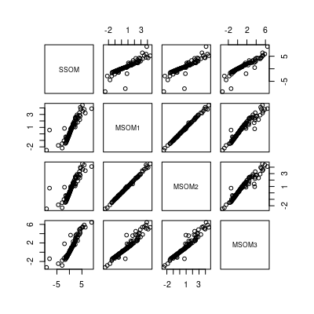 | 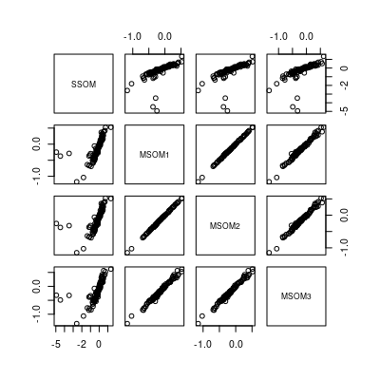
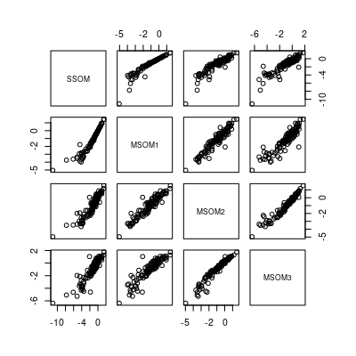 | Figure 2: Pairwise comparison of coefficient estimates from the four different model versions. Upper left: elevation (detection model), upper right (bio12, state model), lower left: detection probability (detection model intercept).
Trait effects on detection probability
An initial plot of the trait effects estimated by MSOM2 seems to be in agreement with hypothesis 1, although further investigation (higher detection probability for large, colourful species) is needed:

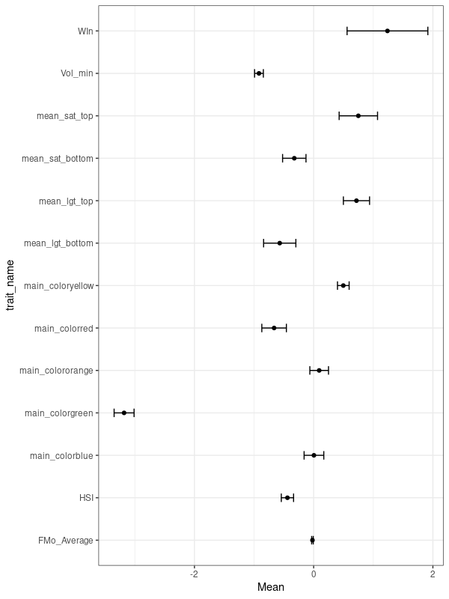
Discussion
- Although the dataset is generally quite large, the analysis of trait effects is essentially based on 105 data points (one value per species). Any ideas on how to increase statistical power?
- Options for follow-up analysis:
  - Calculate community means of trait syndromes → undersampling in some habitats due to community rather than site characteristics?
  - Relate traits to protection status?
  - Assess transferability of trait-detectability-relationships to independent dataset?

Discussion
- Flight activity may be more important than visual apparency (see e.g. Dennis et al. (2006)
- Detectability may vary widely within species, depending on site conditions during survey (Riva et al. 2020)
- [Florian] Detectability of species may strongly depend on the presence/absence of other species, for example if one species in a group of hard-to-tell-apart species is super common, it may be less likely to find a second (similar) but much rarer species
- [Florian] traits used for detectability predictors may have different effects depending on the habitat, and the trait diversity of other species present.
- [Florian] I think the correction of trait-non-independence in a phylogenetic perspective may be needed.

References
BDM coordination office. 2014. Swiss Biodiversity Monitoring BDM. Federal Office for the Environment, Bern.
Boakes, E. H., P. J. K. McGowan, R. A. Fuller, D. Chang-qing, N. E. Clark, K. O’Connor, and G. M. Mace. 2010. Distorted Views of Biodiversity: Spatial and Temporal Bias in Species Occurrence Data. PLOS Biology 8:1000385.
Buckland, S. T., D. R. Anderson, K. P. Burnham, and J. L. Laake. 1993. Distance Sampling: Estimating Abundance of Biological Populations. Chapman & Hall.
Buckley, L. B., S. A. Waaser, H. J. MacLean, and R. Fox. 2011. Does including physiology improve species distribution model predictions of responses to recent climate change? Ecology 92:2214–2221.
Chen, G., M. Kéry, M. Plattner, K. Ma, and B. Gardner. 2013. Imperfect detection is the rule rather than the exception in plant distribution studies. Journal of Ecology 101:183–191.
Dennis, R. L. H., J. G. Hodgson, R. Grenyer, T. G. Shreeve, and D. B. Roy. 2004. Host plants and butterfly biology. Do host-plant strategies drive butterfly status? Ecological Entomology 29:12–26.
Dennis, R. L. H., T. G. Shreeve, N. J. B. Isaac, D. B. Roy, P. B. Hardy, R. Fox, and J. Asher. 2006. The effects of visual apparency on bias in butterfly recording and monitoring. Biological Conservation 128:486–492.
Dorazio, R. M., J. A. Royle, B. Söderström, and A. Glimskär. 2006. Estimating Species Richness and Accumulation by Modeling Species Occurrence and Detectability. Ecology 87:842–854.
Garrard, G. E., M. A. McCarthy, N. S. G. Williams, S. A. Bekessy, and B. A. Wintle. 2013. A general model of detectability using species traits. Methods in Ecology and Evolution 4:45–52.
Grand, J., M. P. Cummings, T. G. Rebelo, T. H. Ricketts, and M. C. Neel. 2007. Biased data reduce efficiency and effectiveness of conservation reserve networks. Ecology Letters 10:364–374.
Guillera‐Arroita, G. 2017. Modelling of species distributions, range dynamics and communities under imperfect detection: advances, challenges and opportunities. Ecography 40:281–295.
Hallmann, C. A., M. Sorg, E. Jongejans, H. Siepel, N. Hofland, H. Schwan, W. Stenmans, A. Müller, H. Sumser, T. Hörren, D. Goulson, and H. de Kroon. 2017. More than 75 percent decline over 27 years in total flying insect biomass in protected areas. PLOS ONE 12:e0185809.
Hanspach, J., O. Schweiger, I. Kühn, M. Plattner, P. B. Pearman, N. E. Zimmermann, and J. Settele. 2014. Host plant availability potentially limits butterfly distributions under cold environmental conditions. Ecography 37:301–308.
Hijmans, R. J., and van Etten J. 2012, January 1. raster: Geographic analysis and modeling with raster data.
Hinks, A. E., E. F. Cole, K. J. Daniels, T. A. Wilkin, S. Nakagawa, and B. C. Sheldon. 2015. Scale-Dependent Phenological Synchrony between Songbirds and Their Caterpillar Food Source. The American Naturalist 186:84–97.
Isaac, N. J. B., K. L. Cruickshanks, A. M. Weddle, J. M. Rowcliffe, T. M. Brereton, R. L. H. Dennis, D. M. Shuker, and C. D. Thomas. 2011. Distance sampling and the challenge of monitoring butterfly populations. Methods in Ecology and Evolution 2:585–594.
Jennersten, O. 1984. Flower visitation and pollination efficiency of some North European butterflies. Oecologia 63:80–89.
Johnson, D. H. 2008. In Defense of Indices: The Case of Bird Surveys. The Journal of Wildlife Management 72:857–868.
Kellner, K. 2019. jagsUI: A Wrapper Around “rjags” to Streamline “JAGS” Analyses.
Kendall, W. L., J. D. Nichols, and J. E. Hines. 1997. Estimating Temporary Emigration Using Capture–Recapture Data with Pollock’s Robust Design. Ecology 78:563–578.
Kéry, M. M. M., and J. A. Royle. 2016. Applied Hierarchical Modeling in Ecology: Analysis of distribution, abundance and species Richness in R and BUGS. Elsevier Academic Press, Amsterdam; Boston; Heidelberg.
Kéry, M., and J. A. Royle. 2008. Hierarchical Bayes estimation of species richness and occupancy in spatially replicated surveys. Journal of Applied Ecology 45:589–598.
Kéry, M., J. A. Royle, M. Plattner, and R. M. Dorazio. 2009. Species richness and occupancy estimation in communities subject to temporary emigration. Ecology 90:1279–90.
Kissling, M. L., and E. O. Garton. 2006. Estimating Detection Probability and Density from Point-Count Surveys: A Combination of Distance and Double-Observer Sampling. The Auk 123:735–752.
Kral‐O’Brien, K. C., B. M. Karasch, T. J. Hovick, R. A. Moranz, and J. P. Harmon. 2020. Morphological traits determine detectability bias in North American grassland butterflies. Ecosphere 11:e03304.
Kremen, C., N. M. Williams, M. A. Aizen, B. Gemmill‐Herren, G. LeBuhn, R. Minckley, L. Packer, S. G. Potts, T. Roulston, I. Steffan‐Dewenter, D. P. Vázquez, R. Winfree, L. Adams, E. E. Crone, S. S. Greenleaf, T. H. Keitt, A.-M. Klein, J. Regetz, and T. H. Ricketts. 2007. Pollination and other ecosystem services produced by mobile organisms: a conceptual framework for the effects of land-use change. Ecology Letters 10:299–314.
Lewis, O. T., and M. J. M. Senior. 2011. Assessing conservation status and trends for the world’s butterflies: the Sampled Red List Index approach. Journal of Insect Conservation 15:121–128.
MacKenzie, D. I., J. D. Nichols, G. B. Lachman, S. Droege, J. A. Royle, and C. A. Langtimm. 2002. Estimating site occupancy rates when detection probabilities are less than one. Ecology 83:2248–2255.
MacKenzie, D. I., J. D. Nichols, J. A. Royle, K. H. Pollock, L. Bailey, and J. E. Hines. 2006. Occupancy Estimation and Modeling: Inferring Patterns and Dynamics of Species Occurrence. Elsevier Science.
Middleton-Welling, J., L. Dapporto, E. García-Barros, M. Wiemers, P. Nowicki, E. Plazio, S. Bonelli, M. Zaccagno, M. Šašić, J. Liparova, O. Schweiger, A. Harpke, M. Musche, J. Settele, R. Schmucki, and T. Shreeve. 2020. A new comprehensive trait database of European and Maghreb butterflies, Papilionoidea. Scientific Data 7:351.
Moilanen, A., M. C. Runge, J. Elith, A. Tyre, Y. Carmel, E. Fegraus, B. A. Wintle, M. Burgman, and Y. Ben-Haim. 2006. Planning for robust reserve networks using uncertainty analysis. Ecological Modelling 199:115–124.
Nichols, J. D., J. E. Hines, J. R. Sauer, F. W. Fallon, J. E. Fallon, and P. J. Heglund. 2000. A Double-Observer Approach for Estimating Detection Probability and Abundance From Point Counts. The Auk 117:393–408.
Park, T., and G. Casella. 2008. The Bayesian Lasso. Journal of the American Statistical Association 103:681–686.
Pellet, J., J. T. Bried, D. Parietti, A. Gander, P. O. Heer, D. Cherix, and R. Arlettaz. 2012. Monitoring Butterfly Abundance: Beyond Pollard Walks. PLOS ONE 7:e41396.
Plummer, M. 2017. JAGS Version 4.3.0 user manual.
Plummer, M. 2019. rjags: Bayesian Graphical Models using MCMC.
Plummer, M., N. Best, K. Cowles, and K. Vines. 2006. CODA: Convergence Diagnosis and Output Analysis for MCMC. R News 6:711.
Pollard, E. 1977. A method for assessing changes in the abundance of butterflies. Biological Conservation 12:115–134.
R Core Team. 2019, January 1. R: A language and environment for statistical computing. Vienna, Austria.
Riva, F., G. Gentile, S. Bonelli, J. H. Acorn, F. V. Denes, A. D. Crosby, and S. E. Nielsen. 2020. Of detectability and camouflage: evaluating Pollard Walk rules using a common, cryptic butterfly. Ecosphere 11:e03101.
Rosenberg, K. V., A. M. Dokter, P. J. Blancher, J. R. Sauer, A. C. Smith, P. A. Smith, J. C. Stanton, A. Panjabi, L. Helft, M. Parr, and P. P. Marra. 2019. Decline of the North American avifauna. Science 366:120–124.
Rota, C. T., R. J. F. Jr, R. M. Dorazio, and M. G. Betts. 2009. Occupancy estimation and the closure assumption. Journal of Applied Ecology 46:1173–1181.
van Swaay, C. A., E. B. Dennis, R. Schmucki, C. Sevilleja, M. Balalaikins, M. Botham, N. Bourn, T. Brereton, J. P. Cancela, and B. Carlisle. 2019. The EU Butterfly Indicator for Grassland species: 1990-2017. Technical report. Butterfly Conservation Europe.
van Swaay, C., A. Cuttelod, S. Collins, D. Maes, M. L. Munguira, M. Šašić, J. Settele, R. Verovnik, T. Verstrael, and M. Warren. 2010. European red list of butterflies. Publications Office of the European Union, Luxembourg.
Thomas, J. a. 2005. Monitoring change in the abundance and distribution of insects using butterflies and other indicator groups. Philosophical Transactions of the Royal Society B: Biological Sciences 360:339–357.
Tyre, A. J., B. Tenhumberg, S. A. Field, D. Niejalke, K. Parris, and H. P. Possingham. 2003. Improving Precision and Reducing Bias in Biological Surveys: Estimating False-Negative Error Rates. Ecological Applications 13:1790–1801.
Václavík, T., and R. K. Meentemeyer. 2009. Invasive species distribution modeling (iSDM): Are absence data and dispersal constraints needed to predict actual distributions? Ecological Modelling 220:3248–3258.
Warren, M. S., D. Maes, C. A. M. van Swaay, P. Goffart, H. V. Dyck, N. A. D. Bourn, I. Wynhoff, D. Hoare, and S. Ellis. 2021. The decline of butterflies in Europe: Problems, significance, and possible solutions. Proceedings of the National Academy of Sciences 118.
Wickham, H., M. Averick, J. Bryan, W. Chang, L. D. McGowan, R. François, G. Grolemund, A. Hayes, L. Henry, J. Hester, M. Kuhn, T. L. Pedersen, E. Miller, S. M. Bache, K. Müller, J. Ooms, D. Robinson, D. P. Seidel, V. Spinu, K. Takahashi, D. Vaughan, C. Wilke, K. Woo, and H. Yutani. 2019. Welcome to the tidyverse. Journal of Open Source Software 4:1686.
Zeuss, D., S. Brunzel, and R. Brandl. 2017. Environmental drivers of voltinism and body size in insect assemblages across Europe. Global Ecology and Biogeography 26:154–165.
Zipkin, E. F., J. Andrew Royle, D. K. Dawson, and S. Bates. 2010. Multi-species occurrence models to evaluate the effects of conservation and management actions. Biological Conservation 143:479–484.

